ITERATION 2 (more focused on our topic)

PERSONA: Energetic Millennial Kara

TOPIC: Mobility

**EMPATHISE AND DEFINE:**



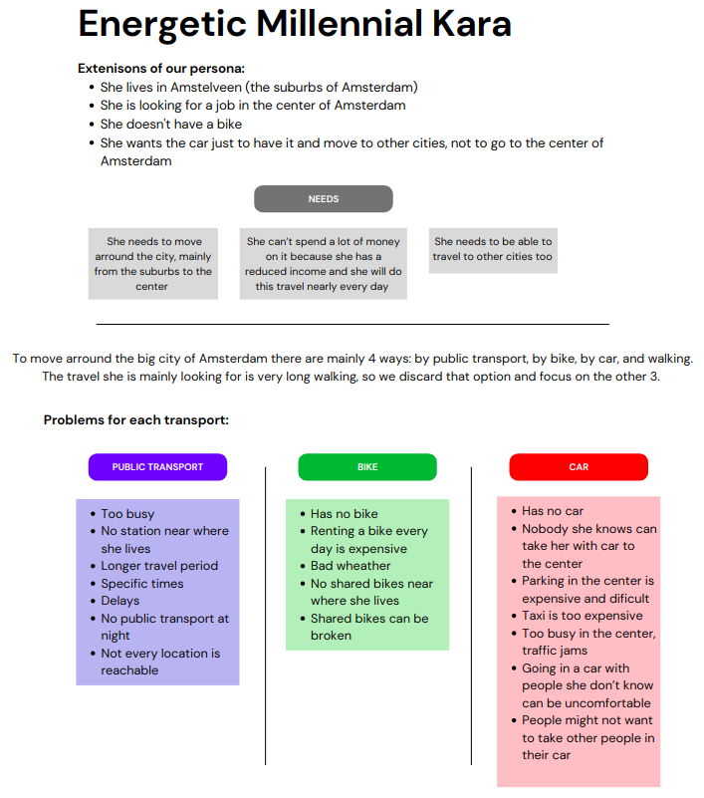

For the topic we got, mobility, we had to add some extensions to our persona because is very diferent the mobility depending on the place she live.

**Extenisons of our persona:**

* She lives in Amstelveen (the suburbs of Amsterdam)
* She is looking for a job in the center of Amsterdam
* She doesn’t have a bike
* She wants the car just to have it and move to other cities, not to go to the center of Amsterdam

**Needs:**

* She needs to move arround the city, mainly from the suburbs to the center
* She can’t spend a lot of money on it because she has a reduced income and she will do this travel nearly every day
* She needs to be able to travel to other cities too

**Problems to solve:**

* She needs an easy way to go from anywhere to anywhere, specialy from the suburbs to the center
* It has to be cheap and affordable because she has a reduced income and she might want to do this travel every day of the week
* She does not have a personal bike to use it
* Public transport is not always the best option
* A taxi is way to expensive if she travels alone
* Nobody known in her surroundings can drop her off at the center

**How might we questions:**

* How might we get an easy way to move arround the city?
* How might we get a cheap way for that?
* How might we get the best option?
* How might we get an easy way to travel to other cities?

To move arround the big city of Amsterdam there are mainly 4 ways: by public transport, by bike, by car, and walking. The travel she is mainly looking for is very long walking, so we discard that option and focus on the other 3.

**Problem statements for each transport:**

Public Transport:

* It is too busy in the public transport some times
* She lives too far from the stations so it takes her some time to get there
* Public transport has usually a longer travel period
* Public transport has specific times so you do not have a lot of freedom when you are traveling
* Public transport can have delays
* There is no public transport at night
* Not every location is reachable with public transport

Problem explanation:

* Our persona needs to go to the center of the city for her work but she is uncomfortable in the public transport because how busy it is.
* Our persona needs to take public transport for her work but it is to expensive to use it every day.
* Our persona needs to take public transport for her work but she lives to far away of any station to get on the train.
* Our persona needs to take public transport for her work but her work is to far away from any public transport station.
* Our persona needs to take public transport for her work but the public transport has a longer travel period than other options.
* Our persona needs to take public transport for her work but the public transport rides on specific times so she has to be really early on work or to late.
* Our persona needs to take public transport for her work but the public transport in her area has a always delay.
* Our persona needs to take public transport for to go home but when she has to work late there are no more busses or trains available to get home.
* Our persona needs to take public transport for her work but not every location is reachable with public transport.
* Our persona needs to take public transport to see her friends but she always have to leave early because there is no public transport at night.

Bike:

* She does not have a bike
* Renting a bike every day of the week is too expensive
* When the weather is bad the bike is not a nice way to travel around
* There are no shared bikes in her neighbourhood
* Shared bikes can be broken and if it is the only one in the neighbourhood you have no bike
* The shared bikes available can be far from where she lives

Problem explanation:

* Our persona needs a bike to reach the center of the city but she does not have a bike.
* Our persona needs to take public transport for her work but renting a bike every day of the week is to expensive.
* Our persona needs to take public transport for her work but when the weather is bad she has to go through it in the morning and does she has a bad day at work.
* Our persona needs to take public transport for her work but there are no renting bikes available in her neighbourhood.
* Our persona needs to take public transport for her work but rental bikes are not always good, so they may be broken.

Car:

* She has no car
* Nobody she knows can take her with car to the center
* Parking in the center is expensive and dificult
* Taxi is too expensive
* It is too busy in the center and there are traffic jams
* Going in a car with people she don’t know can be uncomfortable
* People might not want to take other people in their car

Problem explanation:

* Our persona needs to go to the center of the city for work, but parking your car in the center is way to expensive if you have to do it every day.
* Our persona needs to go to the center of the city for work but she has no car so she can't travel to the center.
* Our persona needs to go to the center of the city for work but it is way to busy in the center of the city so she will be stuck in a traffic jam.

We will focus mainly in the car problems. For the public transport she has Google Maps, NS or 9292, which indicate her all the possible ways and combinations of public transport to go from anywhere to anywhere at any time.

For the bike, there are brands like Bolt, Flickbike or Hellobike, which allow her to pick a bike somewhere in the city and drop it in an other place. There are also a lot of ways to rent your own bike.

For the car, the easiest way would be that someone takes her to the place she want and drop her off there, but she doesn’t know anybody to do that for her, an alternative way to do that is with a taxi, which is too expensive if it’s just for one person. So we will focus on finding other people that does the same travel as her so that they all can order a taxi and share the cost, or if someone in the group has a car and can drive it, because she has parking in the center or for whatever reason, that person can take the rest of the groups with his/her car and then divide the gas spent. This option also allows her to go to other cities, the point is to find more people that does the same travel as her and that they can share the cost of it, even if it is of a taxi or of someone else car.

**IDEATION:**

Solutions have to be cheap because she doesn’t have a lot of money and has to save up for a car.

**IDEAS**:

* App to find people that go by car to the same place as you and share the costs (Carpool)
* Find all the public transport options to go somewhere
* An app to find second hand or cheap cars
* An app to see all rental bikes in the neigbourhood
* A taxi booking app
* Share a taxi app; share a taxi with someone to lower the costs
* Community app for people who want to go in the same direction and time
* Public transportation app
* She needs an app which can help her find a bike she can rent to go to the center of a city.
* An app which compares all the possible ways and vehicles and gives you the best one to go somewhere

**Similar apps:**

* Google Maps: It has all the public transport and routes you have to do or take to go anywhere from anywhere.
* Bla Bla Car: It’s an app to find people that goes to the same place as you and join one of that people’s car to share the costs of the travel.
* Google Maps, NS, 9292, Omio: Public transportation app to find the best route for your travelling.
* Bolt: It's an app were you can order a taxi (local people), but you can also rent steps and scooter. You can pay in the app and you can leave reviews in there.
* Uber: Is also an app were you can order a taxi. Also you can pay in the app and leave reviews.
* Taxi.eu: Is an app were you can order a taxi and pay it. You can leave a review there if you want.
* Wallapop, Markplaats: Apps for buying and selling second hand things: clothes, cars, bikes, …

Main Idea:

An app to find people that does the same travel as you at a similar time, then you will be able to make groups with that people and share a car if someone has or order a taxi.

**PROTOTYPING:**

**Requirements:**

* Location description
* Accounts
* Options to choose who you want to travel with
* Maximum seats in car or taxi
* I have a car, I don’t have a car system
* “A map were you can order a taxi nearby”
* Review system
* Paying system
* Calculate the costs of travel
* Chat for people to meet up
* Meetingpoint and time
* Privacy and safety
* User friendly
* Playfull
* Intelligent

In the home screen of the app you will be able to choose where you are, where you want to go and at what time, then you will see al the people with the same input (time&where) and you will be able to choose with who you want to travel with. People that have a car can introduce it with the amount of free seats it has, otherwise the groups will be at most of 4, to fit in a taxi. The groups in which one person has a car will meet at the time and place the drives says, and the other groups will have the option to call a taxi.

In this second iteration we tried to do more prototypes to have more options to choose. We did those on paper because it’s easier for us to create things without a software limiting us.

It’s not important to build the hole app with all it’s features, which is a thing that will take a lot of time and will be difficult to code. We have to focus on the main parts and make them achieve all the steps of the UX Piramid. The part we have focused on is the mecanism of finding people that does the same travel as you.

The hole app:

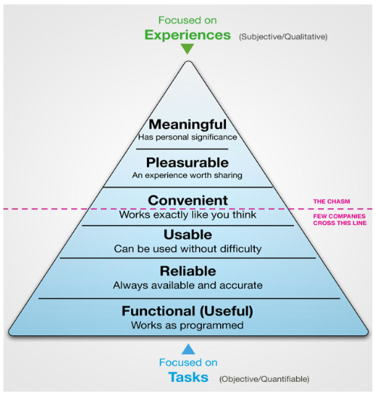

What we have to achieve:



**Future Implementations and Improvements**

To make our product better in the future we will consider all the options to travel. So the app will not only show you the car option, but also the public transport and the bike, saying for each option how long does it take, the route, the cost,… . The app will give you the best option of the travel you are looking for also considering the parking space, rush our, etc.

Also we would like to create a community were you can add your favorite travelers. So in the case you shared car or taxi with someone else and you had a good experience with you can add him/her to favorites and the future travels he/she does will be shown to you first, so you can travel again with him/her if the travell is convenient for you.

We can also make the app more inteligent and give suggestions of the travel you will need at a certain time or day. So taking into account all the past travels you have done the app will know your schedules and daily or weekly travels and when that time comes it will give you the options for the travel you need without you having to ask the app. For example, if you go to work everyday at 8 am, then the app will know that and will authomaticaly show you the possible ways to travel to work from your location at the time you always go.

**TESTING:**